Concept:
- LED Bike Helmet Cover with turn and stop signals.

Problems:
- Bicyclists need increased visibility at night.
- Hand turn signals can be easily missed by motorists, especially in rainy conditions.
- Turn signals that attach to the bike itself can be subject to theft and or damage while the bike is parked.
- LED jackets are effective but restrict the rider to that particular garment.
- In a pace line, where several bikes ride directly behind each other to minimize wind resistance, the typical signal to slow or stop is to place your open hand behind your back. This creates a dangerous problem as the slowing riders in the pace line, all have to remove their hands from the brakes.

Solution:
- A LED helmet cover is highly portable and visible. It can fit in a seat bag or jersey pocket when not in use and gives clear signals to motorists and other riders.
- Two push-buttons, are placed inside the rider's glove*, to activate the turn signals. If both buttons are pressed, the stop lights will activate*.
*See Still in Development

Value Proposition:
- An Arduino Lilypad USB is used to control the helmet. The Lilypad USB offers three distinct advantages.
  - It allows the consumer to recharge the 3.7V Lithium-Ion battery with a common micro-USB cable.
  - It is water-resistant.
  - Is easily re-programmed if the user wants to change the light patterns, or change/add sensors.

- With the protection from the helmet cover and suede pouch, the Lilypad will operate in most weather conditions.
- It's not subject to theft like an attachment. And, it can be used on different helmets, allowing the rider to wear their normal clothing.
- The cover gives the rider increased visibility and most importantly, allows the rider to signal motorists, and other riders.
- The rider can signal the pace line without removing their hand from the handlebars.
- Using generic components, the product could be sold for far cheaper than existing similar products, and possibly less than higher end helmet covers that don't have LED's in them.

Results/Conclusion:
- The LED Helmet Cover is highly portable.
- It greatly increases rider visibility and safety, in traffic, and in a pace line.
- The cover can be used on most bike helmets and won't take up space on your rack or seat post.
- The Arduino board allows for convenient battery recharging, and simple user modification.
- The relatively low cost, and sheer cool factor make this product an easy sell to cyclists.

Still in Development:
- Accelerometer controlled brake lights.
- Wireless signal buttons.
- More LED's!!!!!!

Process

Parts List:
- 1 Arduino Lilypad USB
- 1 ADXL335 3.3V analog output accelerometer
- 1 3.7V 1000mA Lithium-Ion battery
- 20 Various color Lilypad LED's
- 2 SMDR60 LED's (for indicator lights)
- 2 330Ω resistors (for indicator lights)
- Helmet cover
- conductive thread
- puffy fabric paint
- 2 push buttons

Step 1: Sew on the LED's
- Use the conductive thread to sew the LED's to the helmet cover
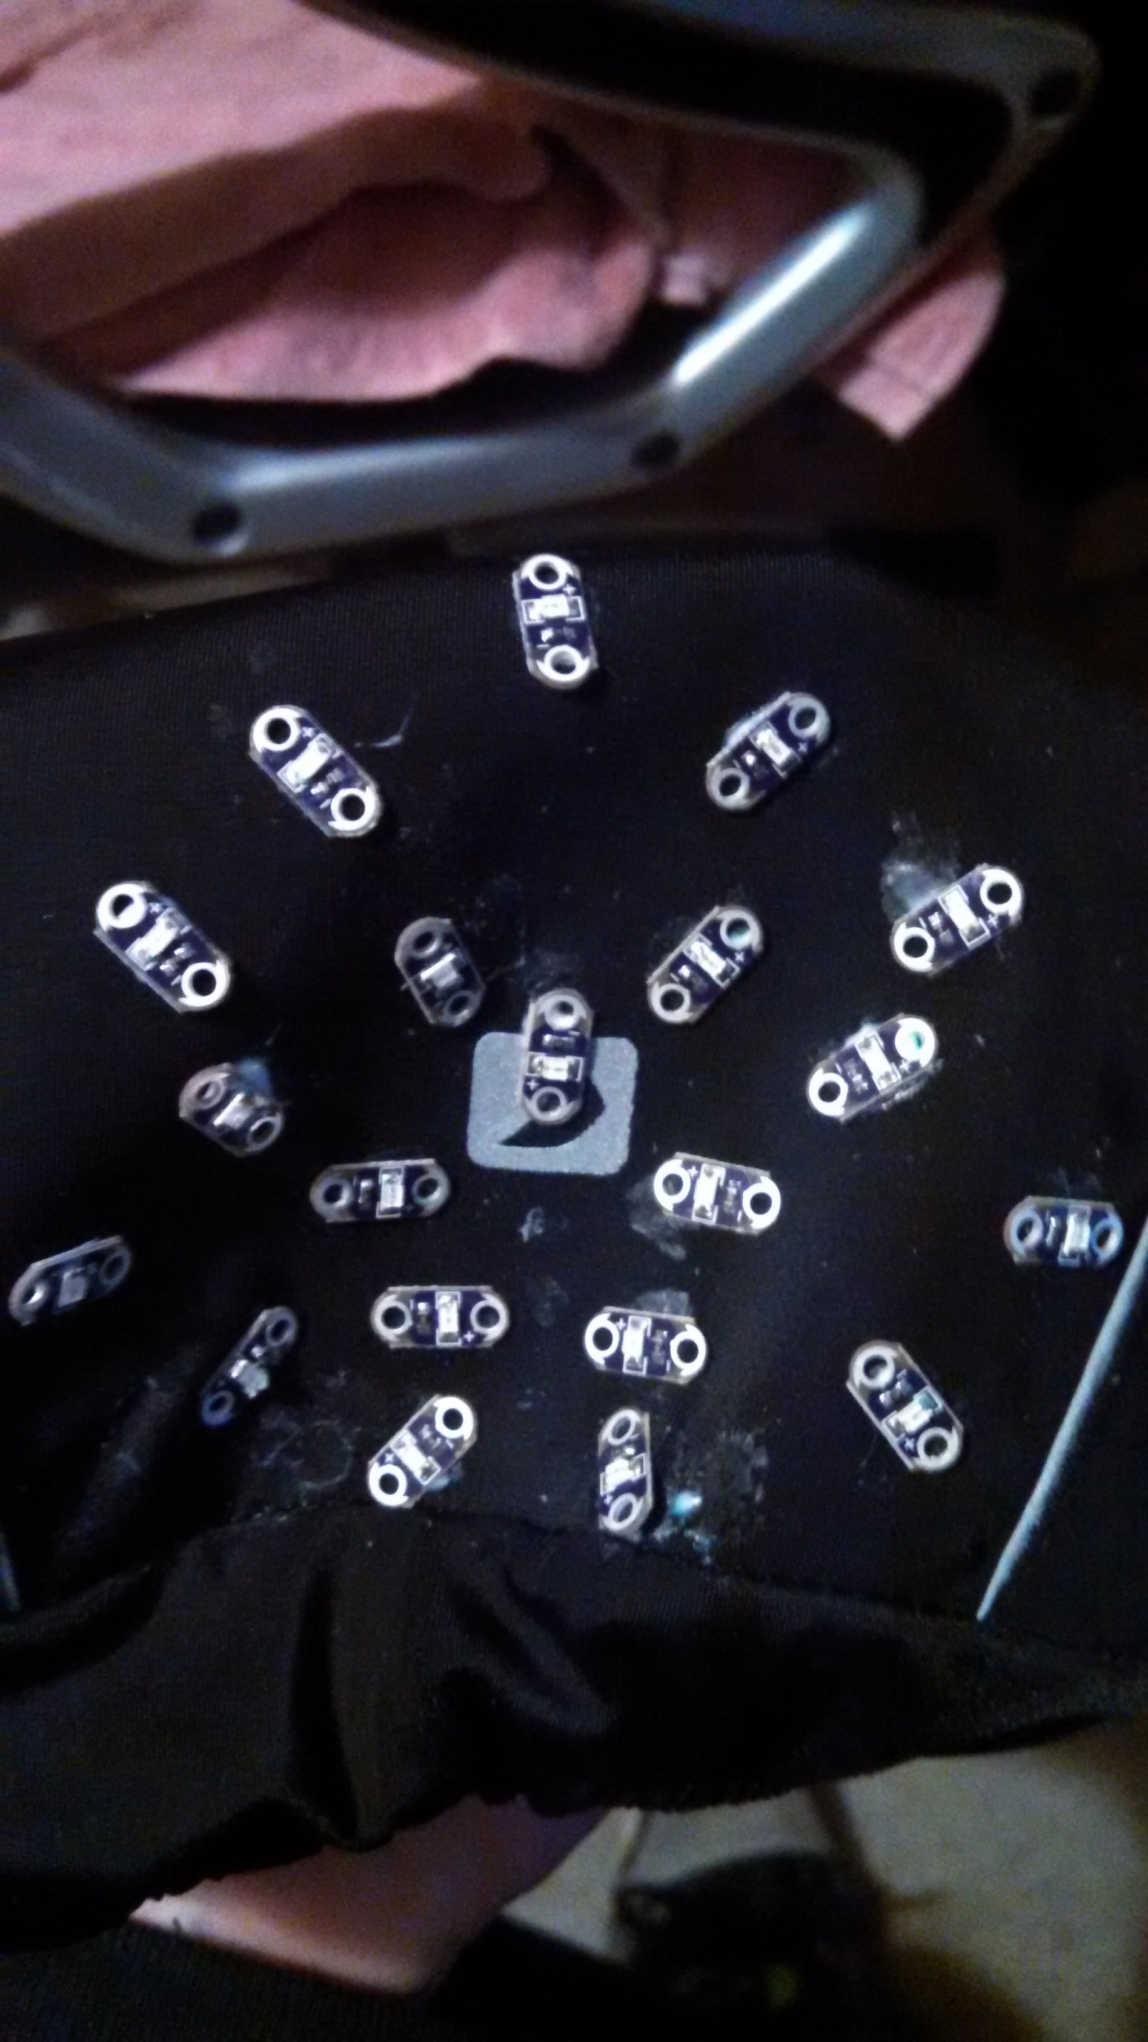


Step 2: Test for conductivity
The conductive thread has a non-trivial resistance of approximately 9 ohms per foot. Test your stitches for resistance, they should read between 3-30 ohms, end to end on each light bank.
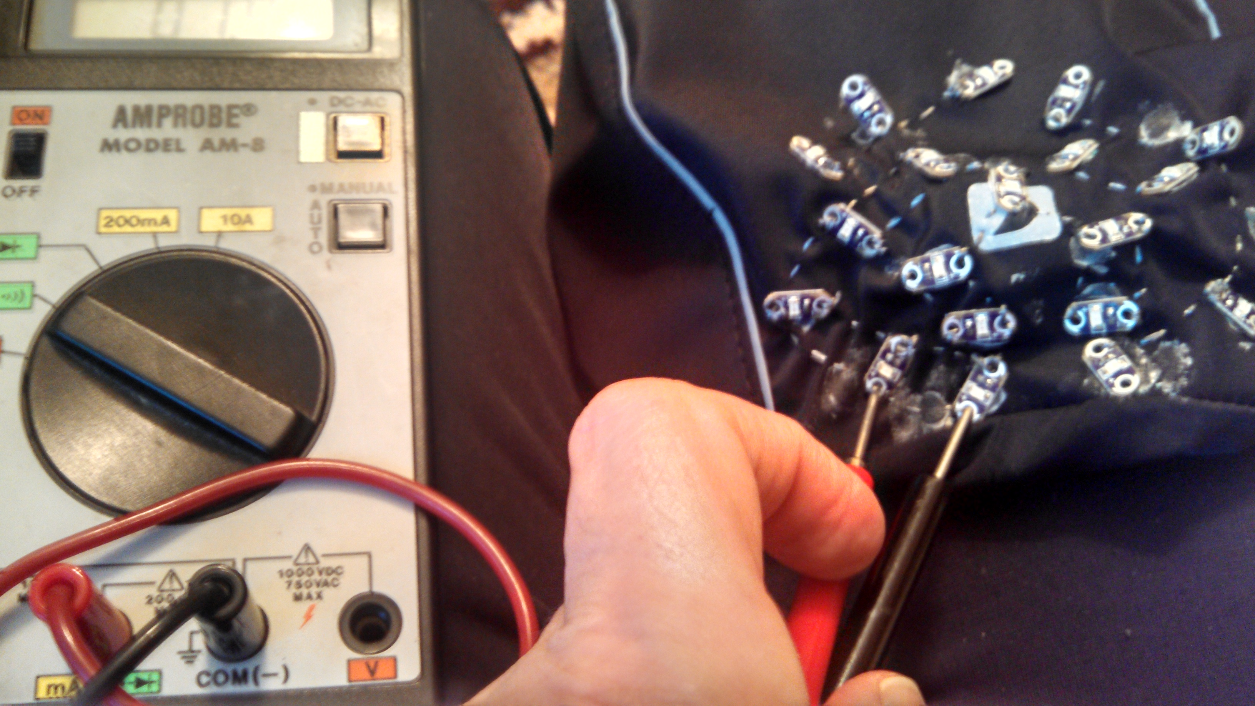
Step 3: Install signal wires
- Unless you have great sewing skills, long stitches increase the chance of a short circuit. I chose to use wires for my signals to negate the resistance of the conductive thread and minimize shorts. Wire up all the lights and buttons at this step.
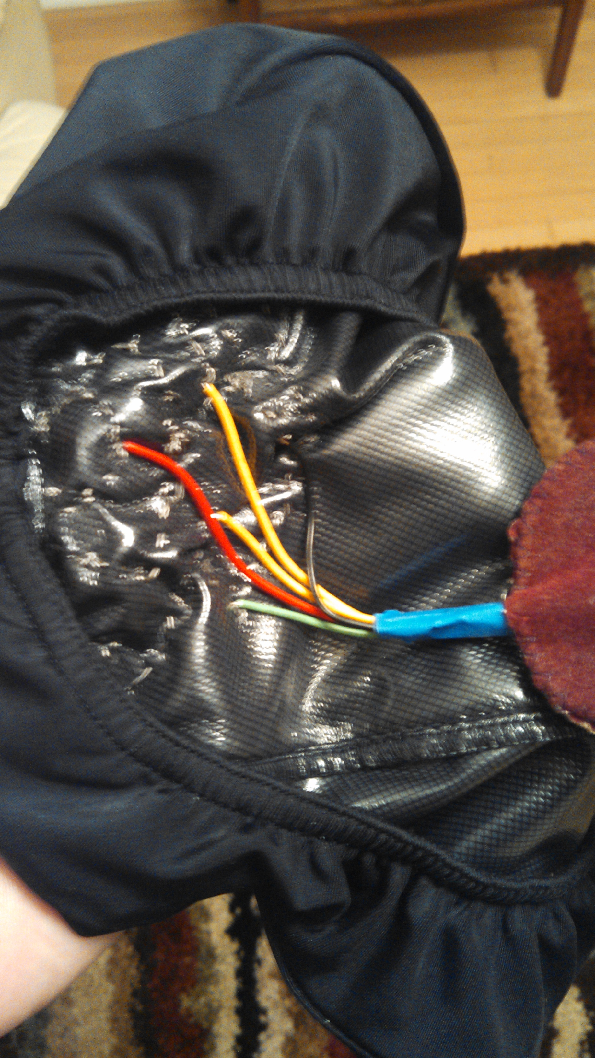
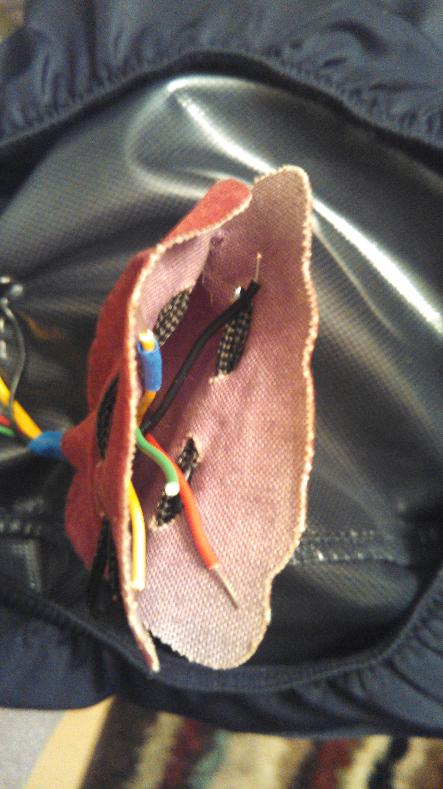

Step 4: Puffy paint the stitches
- Paint your stitches on both sides with puffy fabric paint to protect the circuit from shorting.
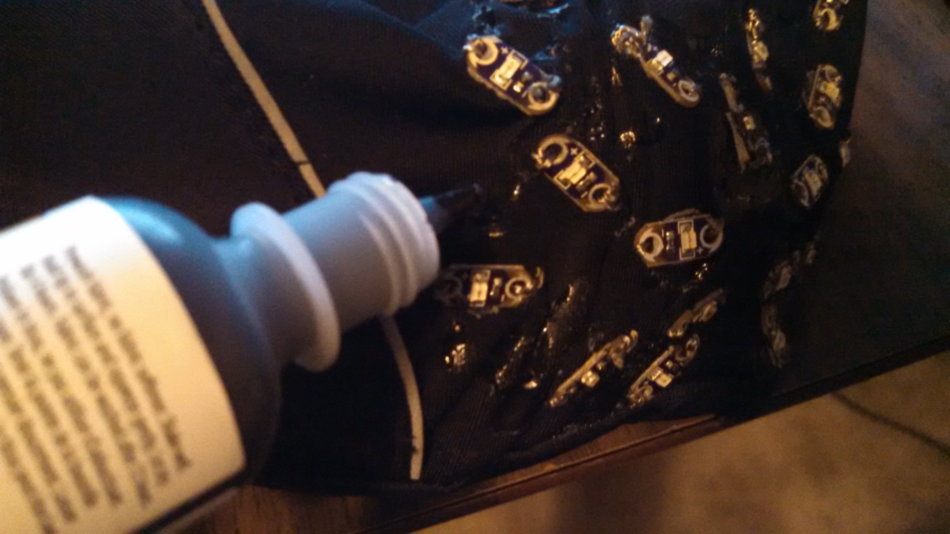
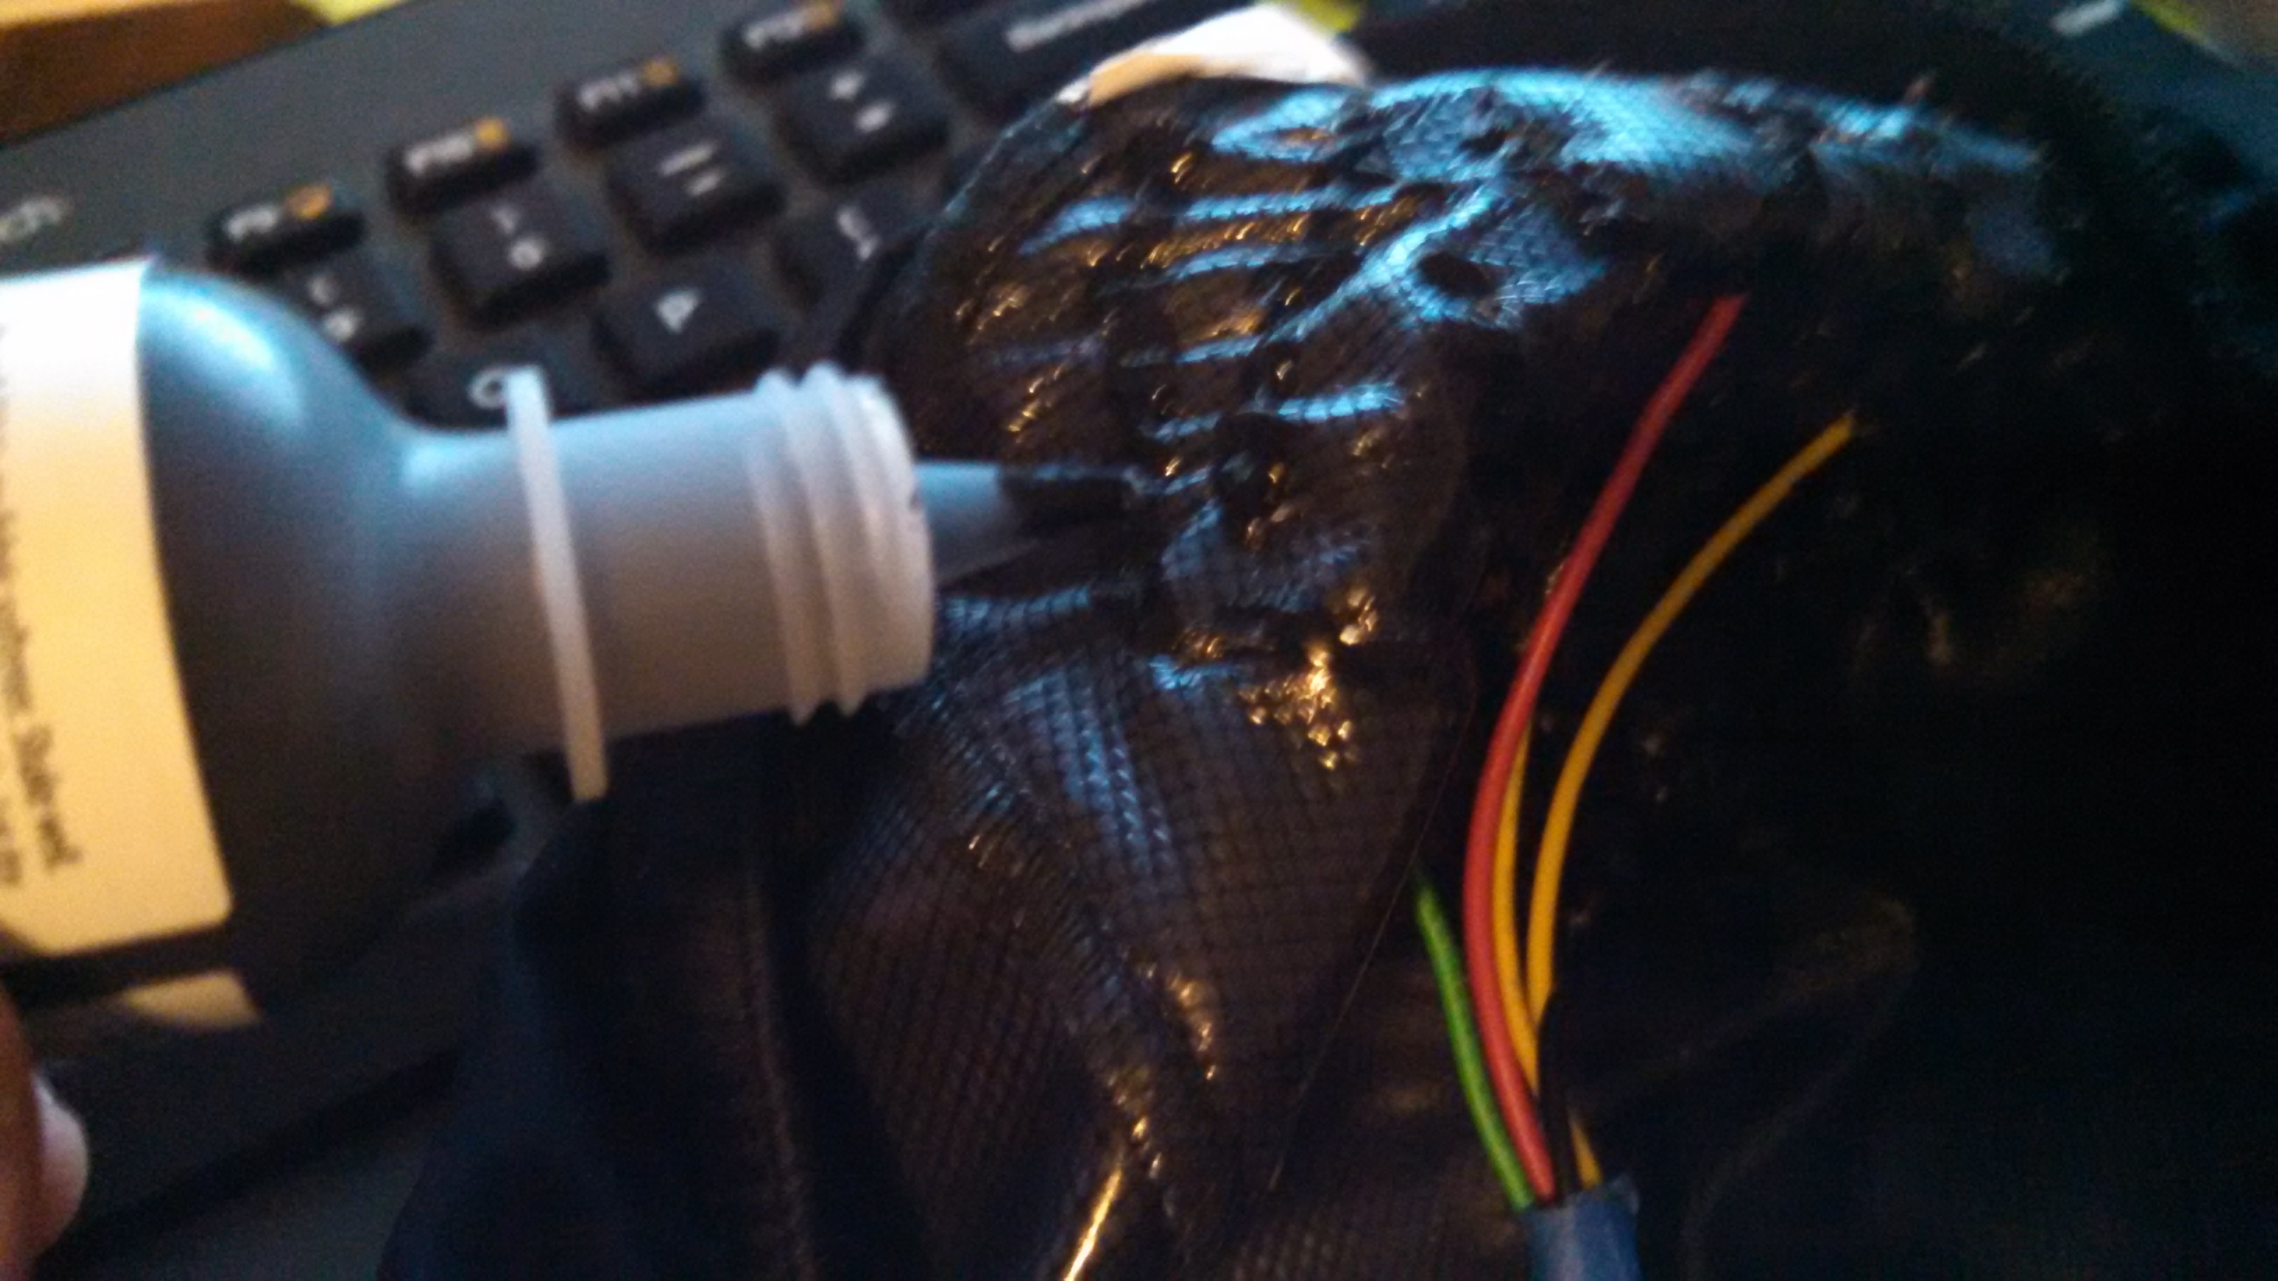

Step 5: Install Lilypad and battery
- The suede pouch helps protect from moisture, and from damaging the micro-controller. I taped the battery to the outside of the pouch in case it gets hot. The accelerometer is also taped to the pouch. This is a good time to upload your code.
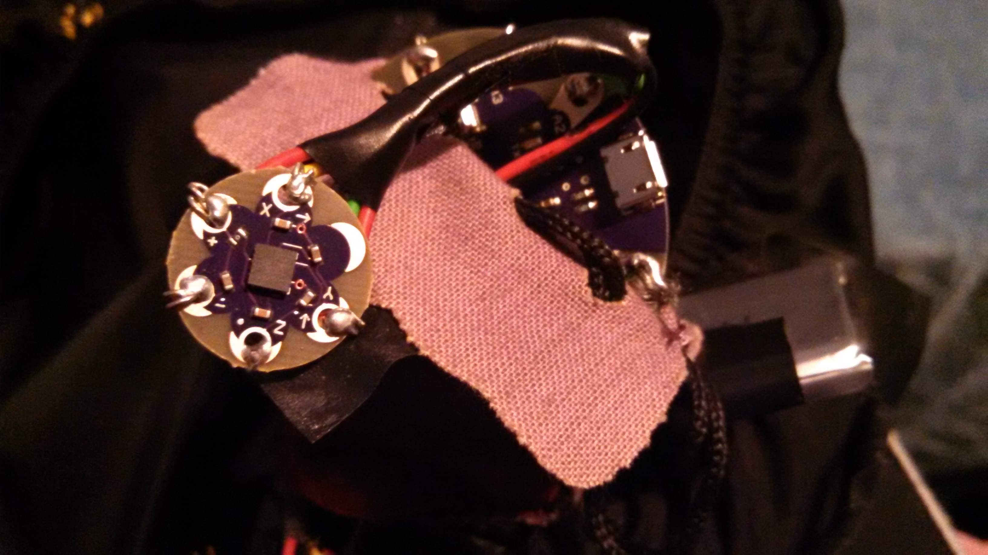

Step 6: Get your project approved and go ride!!
- Make sure Mack thinks your project is cool.


- Go ride with confidence knowing the motorist in traffic or your buddy in the pace line knows whats coming next!


